**Project Initialization and Planning Phase**

| Date | 15 September2024 |
| --- | --- |
| Team ID | 739916 |
| Project Name | Toxic Comment Classification for Social Media using NLP |
| Maximum Marks | 3 Marks |

**Define Problem Statements**

**Problem Statement:**

**The Issue:** The rapid growth of social media has led to an increase in user-generated content, but it has also given rise to the prevalence of toxic comments. These comments can cause significant harm to individuals' mental health, foster negative environments, and discourage user engagement. Traditional methods of moderation are often insufficient, struggling with the volume, diversity, and real-time nature of toxic comments.

**Objective:** To develop an advanced Natural Language Processing (NLP) based classification system that can accurately identify and manage toxic comments in real-time across various social media platforms. This system aims to improve the overall user experience by promoting healthier interactions and reducing the presence of harmful content

**.** 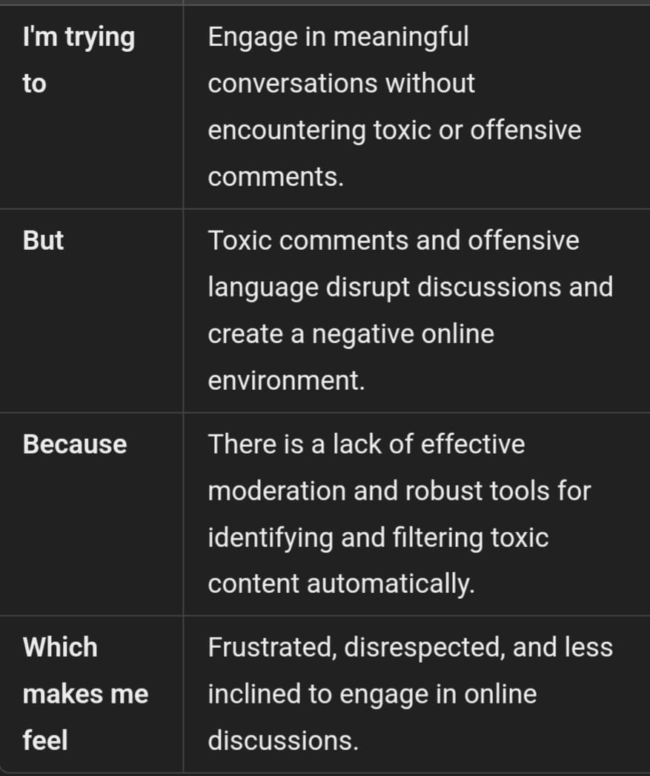

.

**Example:**

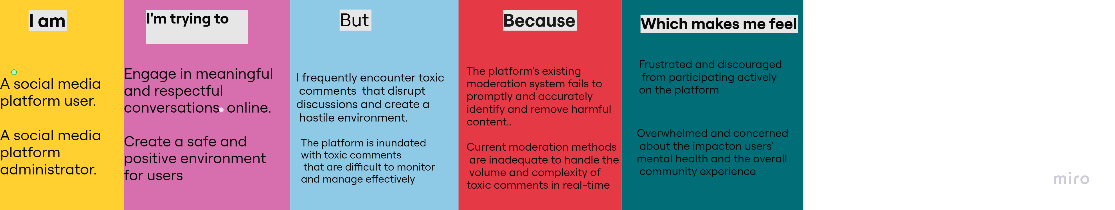

|  |  |  |  |  |  |
| --- | --- | --- | --- | --- | --- |
| **Problem**  **Statement (PS)** | **I am**  **(Customer)** | **I’m trying to** | **But** | **Because** | **Which makes me feel** |
| PS-1 | A social media platform user | Engage in meaningful and respectful conversations online. | I frequently encounter toxic comments that disrupt discussions and create a hostile environment. | The platform's existing moderation system fails to promptly and accurately identify and remove harmful content. | Frustrated and discouraged from participating actively on the platform |
| PS-2 | A social media platform administrator. | Create a safe and positive environment for users. | The platform is inundated with toxic comments that are difficult to monitor and manage effectively. | Current moderation methods are inadequate to handle the volume and complexity of toxic comments in real-time. | Overwhelmed and concerned about the impact on users' mental health and the overall community experience. |